The Basics of Organic Chemistry
When you explore biology, you’ll find that many processes are constantly occurring in living organisms. The study of organic chemistry — which focuses on carbon molecules — is central to all living organisms.
The ability to convert ingested fuel to usable energy is what differentiates a living organism from a dead one. The ingested fuel contains a variety of large molecules (macromolecules) that get broken down. When the macromolecules have been broken down into their smallest parts, they can enter the cells, which contain more macromolecules, which are involved in more processes.

What is organic chemistry?
In organic chemistry, the focus is on the element carbon. Carbon is central to all living organisms; however, thousands of nonliving things (such as drugs, plastics, and dyes) are made from carbon compounds. Diamonds are carbon atoms in a crystal structure. Diamonds are so hard because the atoms of carbon are so closely bonded together in the crystal form. That same ability to pack closely together makes carbon an excellent structural element in its other forms as well.
One atom of carbon can combine with up to four other atoms. Therefore, organic compounds usually are large and can have several atoms and molecules bonded together. Organic molecules can be large, and they comprise the structural components of living organisms: carbohydrates, proteins, nucleic acids, and lipids.

Carbon is key
In their outer shells, carbon atoms have four electrons that can bond with other atoms. When carbon is bonded to hydrogen (which is common in organic molecules), the carbon atom shares an electron with hydrogen, and hydrogen likewise shares an electron with carbon. Carbon-hydrogen molecules are referred to as hydrocarbons. Nitrogen, sulfur, and oxygen also are often joined to carbon in living organisms.

Long carbon chains = low reactivity
Large molecules form when carbon atoms are joined together in a straight line or in rings. The longer the carbon chain, the less chemically reactive the compound is. However, in biology, other measures of reactivity are used. One example is enzymatic activity, which refers to how much more quickly a certain molecule can allow a reaction to occur.
One key to knowing that a compound is less reactive is that its melting and boiling points are high. Generally, the lower a compound’s melting and boiling points, the more reactive it is. For example, the hydrocarbon methane, which is the primary component of natural gas, has just one carbon and four hydrogen atoms. Because it is the shortest carbon compound, it has the lowest boiling point (-162°C) and is a gas at room temperature. It is highly reactive.
On the other hand, a compound made of an extremely long carbon chain has a boiling point of 174°C (compared to water, which has a boiling point of 100°C). Because it takes so much more for it to boil, it is much less reactive and is not gaseous at room temperature.

Forming functional groups based on properties
In organic chemistry, molecules that have similar properties (whether they are chemical or physical properties) are grouped together. The reason they have similar properties is because they have similar groups of atoms; these groups of atoms are called functional groups.
Chemical properties involve one substance changing into another substance by reacting. An example of a chemical property is the ability of chlorine gas to react explosively when mixed with sodium. The chemical reaction creates a new substance, sodium chloride (table salt). Physical properties refer to different forms of a substance, but the substance remains the same; no chemical reaction or change to a new substance occurs.
Some of the properties that the functional groups provide include polarity and acidity. For example, the functional group called carboxyl (-COOH) is a weak acid. Polarity refers to one end of a molecule having a charge (polar), and the other end having no charge (nonpolar). For example, the plasma membrane has hydrophilic heads on the outside that are polar, and the hydrophobic tails (which are nonpolar) form the inside of the plasma membrane.

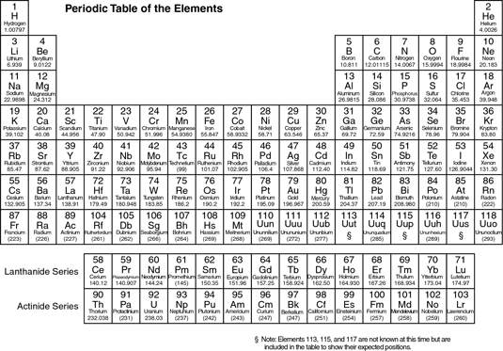

Important Concepts of Organic Chemistry
When you're studying organic chemistry, keep these helpful reminders close by because they highlight some of the most important concepts you'll need to understand organic chemistry:

Electronegativity increases as you go up and to the right in the periodic table.

In reaction mechanisms, arrows show the movement of electrons; the tip of the arrow points to where the electrons are going.

Resonance is a stabilizing feature of molecules; molecular stability generally increases as the number of resonance structures increases.

Bronsted-Lowry acids are proton donors; Bronsted-Lowry bases are proton acceptors.

Strong acids have weak (stable) conjugate bases.

Conformation refers to the way a molecule folds itself in three-dimensional space based on the rotation around carbon-carbon single bonds; configuration (such as R or S configuration of a chiral center or cis or trans configuration of double bonds) refers to the specific orientation of atoms, which can change only through a chemical reaction.

Only chiral molecules have enantiomers; enantiomers rotate plane-polarized light in equal and opposite directions.

Molecules with chiral centers that have a plane of symmetry are called meso compounds; meso compounds are achiral.

In order to have diastereomers, molecules generally have to have two or more chiral centers.

Most organic reactions are driven by an electron-rich species (a nucleophile) attacking an electron-poor species (an electrophile).

Double bonds are stabilized by alkyl substituents.

Tertiary carbocations are more stable than secondary carbocations; secondary carbocations are more stable than primary carbocations. Allylic carbocations and benzylic carbocations are about as stable as secondary carbocations.

Triple bonds are shorter than double bonds; double bonds are shorter than single bonds.

Electrophiles are Lewis acids (electron acceptors); nucleophiles are Lewis bases (electron donors).

Weak bases are good leaving groups; strong bases are bad leaving groups.

Nucleophilicity generally parallels basicity. Typically, strong bases are also good nucleophiles.

Primary halides undergo SN2 substitution; tertiary halides undergo SN1 substitution.

Aromatics have 4n + 2 pi electrons; anti-aromatic compounds have 4n pi electrons.

Substituents on aromatic rings with lone pairs on the ring-attaching atom are ortho-para directors.

You won't get very far in your study of organic chemistry without the periodic table of elements and an understanding of the common functional groups (or reactive centers) that dictate how most of a compound's chemical reactions occur.

Common Functional Groups in Organic Chemistry
In organic chemistry, functional groups (or reactive centers) are small structural units within molecules that dictate how most of the compound's chemical reactions occur. Know these common functional groups you will run into in organic chemistry

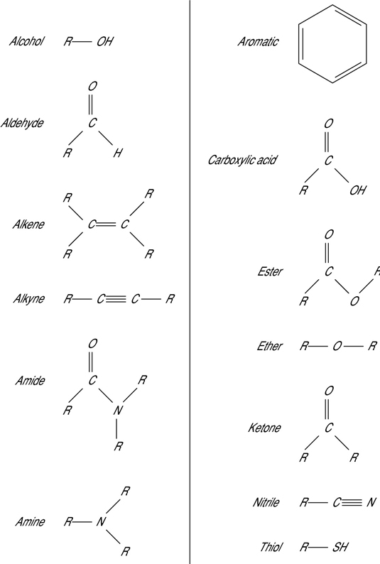

The Essentials of Chemistry Basics
Chemistry is the branch of science that deals with matter, which is anything that has mass and occupies space. You’ll need to get up to speed with some chemistry basics before you explore more complex topics relating to chemical reactions and processes.

How Would You Define Chemistry as a Science?
Chemistry is a branch of science that studies the composition and properties of matter and the changes it undergoes. Chemistry is far more than a collection of facts and a body of knowledge. It’s all about [more…]

The Changing States of Solids, Liquids, and Gases
When a substance goes from one state of matter — solid, liquid, or gas — to another state of matter, the process is a change of state. Some rather interesting things occur during this process. [more…]


How to Distinguish Pure Substances and Mixtures
Chemists can classify matter as solid, liquid, or gas. But there are other ways to classify matter, as well — such as pure substances and mixtures. Classification is one of the basic processes in science [more…]
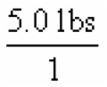

How Scientists Measure Matter
Scientists are often called on to make measurements of matter, which may include such things as mass (weight), volume, and temperature. A worldwide measurement system has been adopted to ensure that scientists [more…]

The Properties of Chemical Substances
When chemists study chemical substances, they examine two types of properties: chemical properties and physical properties. Some physical properties are [more…]

What Are the Different Types of Energy?
Energy can take several forms — such as heat energy, light energy, electrical energy, and mechanical energy. But two general types of energy are especially important to chemists: kinetic energy and potential [more…]
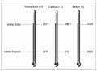

How Is Energy Measured?
You can measure kinetic energy (energy of motion) with a thermometer. Measuring potential (stored) energy can be a difficult task. The potential energy of a ball stuck up in a tree is related to the mass [more…]
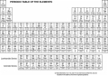

The Periodicity of Chemical Elements
A pattern of repeating order is called periodicity. In the mid-1800s, Dmitri Mendeleev, a Russian chemist, noticed a repeating pattern of chemical properties in elements. [more…]

How Would You Define Chemistry as a Science?

1 of 8 in Series: The Essentials of Chemistry Basics
Chemistry is a branch of science that studies the composition and properties of matter and the changes it undergoes. Chemistry is far more than a collection of facts and a body of knowledge. It’s all about matter, which is anything that has mass and occupies space.
Matter is made up of either pure substances or mixtures of pure substances. The change from one substance into another is what chemists call a chemical change, or chemical reaction, and it’s a big deal because when it occurs, a brand-new substance is created.
The general field of chemistry is so huge that it was originally subdivided into a number of different areas of specialization. But there’s now a tremendous amount of overlap between the different areas of chemistry, just as there is among the various sciences.
Here are the traditional fields of chemistry:

Analytical chemistry: This branch is highly involved in the analysis of substances. Chemists from this field of chemistry may be trying to find out what substances are in a mixture (qualitative analysis) or how much of a particular substance is present (quantitative analysis) in something. A lot of instrumentation is used in analytical chemistry.

Biochemistry: This branch specializes in living organisms and systems. Biochemists study the chemical reactions that occur at the molecular level of an organism — the level where items are so small that people can’t directly see them.

Biochemists study processes such as digestion, metabolism, reproduction, respiration, and so on. Sometimes it’s difficult to distinguish between a biochemist and a molecular biologist because they both study living systems at a microscopic level. However, a biochemist really concentrates more on the reactions that are occurring.

Biotechnology: This is a relatively new area of science that is the application of biochemistry and biology, when creating or modifying genetic material or organisms for specific purposes. It’s used in such areas as cloning and the creation of disease-resistant crops, and it has the potential for eliminating genetic diseases in the future.

Inorganic chemistry: This branch is involved in the study of inorganic compounds such as salts. It includes the study of the structure and properties of these compounds. It also involves the study of the individual elements of the compounds. Inorganic chemists would probably say that it is the study of everything except carbon, which they leave to the organic chemists.

So what are compounds and elements? Just more of the anatomy of matter. Matter is made up of either pure substances or mixtures of pure substances, and substances themselves are made up of either elements or compounds.

Organic chemistry: This is the study of carbon and its compounds. It’s probably the most organized of the areas of chemistry. There are millions of organic compounds, with thousands more discovered or created each year. Industries such as the polymer industry, the petrochemical industry, and the pharmaceutical industry depend on organic chemists.

Physical chemistry: This branch figures out how and why a chemical system behaves as it does. Physical chemists study the physical properties and behavior of matter and try to develop models and theories that describe this behavior.

The Changing States of Solids, Liquids, and Gases

2 of 8 in Series: The Essentials of Chemistry Basics
When a substance goes from one state of matter — solid, liquid, or gas — to another state of matter, the process is a change of state. Some rather interesting things occur during this process.

Melting point as a chemistry concept
If you measure the temperature of a chunk of ice, you may find it to be –5° Celsius or so. If you take temperature readings while heating the ice in a pot on your stove, you find that the temperature of the ice begins to rise as the heat from the stove causes the ice particles to begin vibrating faster and faster.
After a while, some of the particles move so fast that they break free of the crystal lattice (which keeps a solid solid), and the lattice eventually breaks apart. The solid begins to go from a solid state to a liquid state — a process called melting. The temperature at which melting occurs is the melting point (mp) of the substance. The melting point for ice is 32° Fahrenheit, or 0° Celsius.
If you watch the temperature of ice as it melts, you see that the temperature remains steady at 0°C until all the ice has melted. During changes of state (phase changes), the temperature remains constant even though the liquid contains more energy than the ice (because the particles in liquids move faster than the particles in solids).

Boiling point of water
If you heat a pot of cool water, the temperature of the water rises and the particles move faster and faster as they absorb the heat. The temperature rises until the water reaches the next change of state — boiling. As the particles move faster and faster, they begin to break the attractive forces between each other and move freely as steam — a gas.
The process by which a substance moves from the liquid state to the gaseous state is called boiling. The temperature at which a liquid begins to boil is called the boiling point (bp). The bp is dependent on atmospheric pressure, but for water at sea level, it’s 212°F, or 100°C. The temperature of the boiling water will remain constant until all the water has been converted to steam.
You can summarize the process of water changing from a solid to a liquid to a gas in this way:
ice→water→steam
Because the basic particle in ice, water, and steam is the water molecule, the same process can also be shown as:
Here the (s) stands for solid, the (l) stands for liquid, and the (g) stands for gas. Unlike water, most chemical substances don’t have different names for the solid, liquid, and gas forms.

Freezing point of a substance
If you cool a gaseous substance, you can watch the phase changes that occur. The phase changes are:

Condensation — going from a gas to a liquid

Freezing — going from a liquid to a solid

The gas particles have a high amount of energy, but as they’re cooled, that energy is reduced. The attractive forces now have a chance to draw the particles closer together, forming a liquid. This process is called condensation. The particles are now in clumps, but as more energy is removed by cooling, the particles start to align themselves, and a solid is formed. This is known as freezing. The temperature at which this occurs is called the freezing point (fp) of the substance.
You can represent water changing states from a gas to a solid like this:

Sublimation
Most substances go through the logical progression from solid to liquid to gas as they’re heated — or vice versa as they’re cooled. But a few substances go directly from the solid to the gaseous state without ever becoming a liquid. Scientists call this process sublimation. Dry ice — solid carbon dioxide — is the classic example of sublimation. You can see dry ice particles becoming smaller as the solid begins to turn into a gas, but no liquid is formed during this phase change.
The process of sublimation is represented as:
In addition to dry ice, mothballs and certain solid air fresheners also go through the process of sublimation. The reverse of sublimation is deposition — going directly from a gaseous state to a solid state.

How to Distinguish Pure Substances and Mixtures

3 of 8 in Series: The Essentials of Chemistry Basics
Chemists can classify matter as solid, liquid, or gas. But there are other ways to classify matter, as well — such as pure substances and mixtures. Classification is one of the basic processes in science. All matter can be classified as either a pure substance or a mixture.
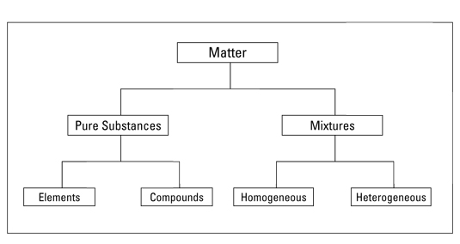
The classification of matter.

Pure substances
A pure substance has a definite and constant composition — like salt or sugar. A pure substance can be either an element or a compound, but the composition of a pure substance doesn’t vary.

Elements
An element is composed of a single kind of atom. An atom is the smallest particle of an element that still has all the properties of the element.
Here’s an example: Gold is an element. If you slice and slice a chunk of gold until only one tiny particle is left that can’t be chopped any more without losing the properties that make gold gold, then you’ve got an atom.
The atoms in an element all have the same number of protons. Protons are subatomic particles — particles of an atom. Elements are the building blocks of matter. And they’re represented in a strange table you may have seen at one time or another — the periodic table.

Compounds
A compound is composed of two or more elements in a specific ratio. For example, water is a compound made up of two elements, hydrogen (H) and oxygen (O). These elements are combined in a very specific way — in a ratio of two hydrogen atoms to one oxygen atom, known as:
Many compounds contain hydrogen and oxygen, but only one has that special 2 to 1 ratio we call water. The compound water has physical and chemical properties different from both hydrogen and oxygen — water’s properties are a unique combination of the two elements.
Chemists can’t easily separate the components of a compound: They have to resort to some type of chemical reaction.

Mixtures
Mixtures are physical combinations of pure substances that have no definite or constant composition — the composition of a mixture varies according to who prepares the mixture.
Although chemists have a difficult time separating compounds into their specific elements, the different parts of a mixture can be easily separated by physical means, such as filtration.
For example, suppose you have a mixture of salt and sand, and you want to purify the sand by removing the salt. You can do this by adding water, dissolving the salt, and then filtering the mixture. You then end up with pure sand.
Mixtures can be either homogeneous or heterogeneous:

A homogeneous mixture, sometimes called a solution, is relatively uniform in composition; every portion of the mixture is like every other portion.

For example, if you dissolve sugar in water and mix it really well, your mixture is basically the same no matter where you sample it.

A heterogeneous mixture is a mixture whose composition varies from position to position within the sample.

For example, if you put some sugar in a jar, add some sand, and then give the jar a couple of shakes, your mixture doesn’t have the same composition throughout the jar. Because the sand is heavier, there’s probably more sand at the bottom of the jar and more sugar at the top.

How Scientists Measure Matter

4 of 8 in Series: The Essentials of Chemistry Basics
Scientists are often called on to make measurements of matter, which may include such things as mass (weight), volume, and temperature. A worldwide measurement system has been adopted to ensure that scientists can speak the same language.

The SI system of scientific measurement
The SI system (from the French Systeme International) is a worldwide measurement system based on the older metric system that most of us learned in school. There are minor differences between the SI and metric systems, but they’re basically interchangeable.
SI is a decimal system with basic units for things like mass, length, and volume, and prefixes that modify the basic units. For example, the prefix kilo- (k) means 1,000. So a kilogram (kg) is 1,000 grams and a kilometer (km) is 1,000 meters.
Two other very useful SI prefixes are centi- (c) and milli- (m), which mean 0.01 and 0.001, respectively. So a milligram (mg) is 0.001 grams — or you can say that there are 1,000 milligrams in a gram.

SI/English conversions
Many years ago, there was a movement in the U.S. to convert to the metric system. But Americans are still buying their potatoes by the pound and their gasoline by the gallon. Most professional chemists use both the U.S. and SI systems without any trouble. It’s necessary to make conversions when using two systems.
The basic unit of length in the SI system is the meter (m). A meter is a little longer than a yard; there are 1.094 yards in a meter, to be exact. But that’s not a really useful conversion. The most useful SI/English conversion for length is:
2.54 centimeters = 1 inch
The basic unit of mass in the SI system for chemists is the gram (g). And the most useful conversion for mass is:
454 grams = 1 pound
The basic unit for volume in the SI system is the liter (L). The most useful conversion is:
0.946 liter = 1 quart

The unit conversion method
You’ll find that it’s often unclear how to actually set up chemistry problems to solve them. A scientific calculator will handle the math, but it won’t tell you what you need to multiply or what you need to divide.
That’s why you need to know about the unit conversion method, which is sometimes called the factor label method. It will help you set up chemistry problems and calculate them correctly.
Two basic rules are associated with the unit conversion method:

Rule 1: Always write the unit and the number associated with the unit. (Rarely in chemistry will you have a number without a unit. The mathematical pi is an exception.)

Rule 2: Carry out mathematical operations with the units, canceling them until you end up with the unit you want in the final answer. In every step, you must have a correct mathematical statement.

For example, suppose that you have a 5-pound sack of potatoes and you want to know its weight in kilograms. Write down 5 pounds (lbs) as a fraction by placing it over 1.
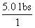
Because you need to cancel the unit lbs in the numerator, you must find a relationship between lbs and something else — and then express that something else with lbs in the denominator. You know the relationship between pounds and grams, so you can use that:
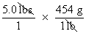
Now simply convert from grams to kilograms in the same way:
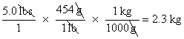

The Properties of Chemical Substances

5 of 8 in Series: The Essentials of Chemistry Basics
When chemists study chemical substances, they examine two types of properties: chemical properties and physical properties. Some physical properties are extensive properties, properties that depend on the amount of matter present. Mass and volume are extensive properties.
Intensive properties, however, don’t depend on the amount of matter present. Color is an intensive property. A large chunk of gold, for example, is the same color as a small chunk of gold. The mass and volume of these two chunks are different (extensive properties), but the color is the same.
Following are descriptions of the two types of properties:

Chemical properties: These properties enable a substance to change into a brand-new substance, and they describe how a substance reacts with other substances. Does a substance change into something completely new when water is added — like sodium metal changes to sodium hydroxide? Does it burn in air?

Physical properties: These properties describe the physical characteristics of a substance. The mass, volume, and color of a substance are physical properties, and so is its ability to conduct electricity.

What is density?
Density is one of the most useful intensive properties of a substance, enabling chemists to more easily identify substances. For example, knowing the differences between the density of quartz and diamond allows a jeweler to check out that engagement ring quickly and easily.
Density (d) is the ratio of the mass (m) to volume (v) of a substance. Mathematically, it looks like this:
d = m/v
Usually, mass is described in grams (g) and volume in milliliters (mL), so density is g/mL.
Because the volumes of liquids vary somewhat with temperature, chemists also usually specify the temperature at which a density measurement is made. Most reference books report densities at 20°C, because it’s close to room temperature and easy to measure without a lot of heating or cooling. The density of water at 20°C, for example, is 1g/mL.
Another term you may sometimes hear is specific gravity (sg), which is the ratio of the density of a substance to the density of water at the same temperature. Specific gravity is just another way for you to get around the problem of volumes of liquids varying with the temperature.
In most cases, the density and specific gravity are almost the same, so it’s common to simply use the density.

Measuring density
Calculating density is pretty straightforward. You measure the mass of an object by using a balance or scale, determine the object’s volume, and then divide the mass by the volume.
Determining the volume of liquids is easy, but solids can be tricky. If the object is a regular solid, like a cube, you can measure its three dimensions and calculate the volume by multiplying the length by the width by the height:
If the object is an irregular solid, like a rock, determining the volume is more difficult. With irregular solids, you can measure the volume by using something called the Archimedes Principle, which states that the volume of a solid is equal to the volume of water it displaces.
Say that you want to measure the volume of a small rock in order to determine its density. Follow these steps:

Put some water into a graduated cylinder with markings for every mL and read the volume.

The example in the following figure shows 25 mL.

Put the rock in the cylinder, making sure that it’s totally submerged, and read the volume again (29 mL in the figure).

The difference in volume (4 mL, in this example) is the volume of the rock.

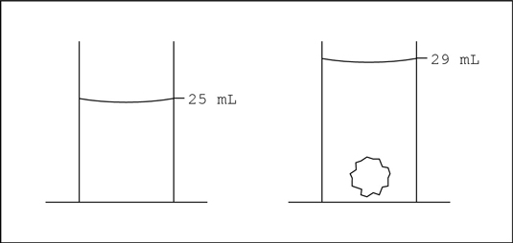

Determining the volume of an irregular solid: The Archimedes Principle.

Anything with a density lower than water will float when put into water, and anything with a density greater than 1 g/mL will sink.
The following table lists the density of some common materials.
Densities of Typical Solids and Liquids in g/mL
Substance | Density
Gasoline | 0.68
Ice | 0.92
Water | 1.00
Table Salt | 2.16
Iron | 7.86
Lead | 11.38
Mercury | 13.55
Gold | 19.3

What Are the Different Types of Energy?

6 of 8 in Series: The Essentials of Chemistry Basics
Energy can take several forms — such as heat energy, light energy, electrical energy, and mechanical energy. But two general types of energy are especially important to chemists: kinetic energy and potential energy.
Energy is one of two components of the universe. Matter is the other component. Energy is the ability to do work.

Kinetic energy
Kinetic energy is energy of motion. A baseball flying through the air toward a batter has a large amount of kinetic energy. Ask anyone who’s ever been hit with a baseball, and they’re likely to agree!
Chemists sometimes study moving particles, especially gases, because the kinetic energy of these particles helps determine whether a particular reaction may take place. The reason is that collisions between particles and the transfer of energy cause chemical reactions to occur.
The kinetic energy of moving particles can be transferred from one particle to another. Have you ever shot pool? You transfer kinetic energy from your moving pool stick to the cue ball to (hopefully) the ball you’re aiming at.
Kinetic energy can be converted into other types of energy. In a hydroelectric dam, the kinetic energy of the falling water is converted into electrical energy. In fact, a scientific law — The Law of Conservation of Energy — states that in ordinary chemical reactions (or physical processes), energy is neither created nor destroyed but can be converted from one form to another.

Potential energy
Suppose you take a ball and throw it up into a tree where it gets stuck. You gave that ball kinetic energy — energy in motion — when you threw it. But where’s that energy now? It’s been converted into the other major category of energy — potential energy.
Potential energy is stored energy. Objects may have potential energy stored in terms of their position. That ball up in the tree has potential energy due to its height. If the ball were to fall, that potential energy would be converted to kinetic energy.
Potential energy due to position isn’t the only type of potential energy. In fact, chemists really aren’t all that interested in potential energy due to position. Chemists are far more interested in the energy stored (potential energy) in chemical bonds, which are the forces that hold atoms together in compounds.
It takes a lot of energy to run a human body. If there were no way to store the energy you extract from food, you’d have to eat all the time just to keep your body going. But humans can store energy in terms of chemical bonds. And then later, when we need that energy, our bodies can break those bonds and release it.
The same is true of the fuels we commonly use to heat our homes and run our automobiles. Energy is stored in these fuels — gasoline, for example — and is released when chemical reactions take place.

How Is Energy Measured?

7 of 8 in Series: The Essentials of Chemistry Basics
You can measure kinetic energy (energy of motion) with a thermometer. Measuring potential (stored) energy can be a difficult task. The potential energy of a ball stuck up in a tree is related to the mass of the ball and its height above the ground. The potential energy contained in chemical bonds is related to the type of bond and the number of bonds that can potentially break.

Temperature and temperature scales
When you measure the air temperature in your backyard, you’re really measuring the average kinetic energy of the gas particles in your backyard. The faster those particles are moving, the higher the temperature is.
Now, all the particles aren’t moving at the same speed. Some are going very fast, and some are going relatively slow, but most are moving at a speed between the two extremes. The temperature reading from your thermometer is related to the average kinetic energy of the particles.
You probably use the Fahrenheit scale to measure temperatures, but most scientists and chemists use either the Celsius (°C) or Kelvin (K) temperature scale. (There’s no degree symbol associated with K.) The following figure compares the three temperature scales using the freezing point and boiling point of water as reference points.
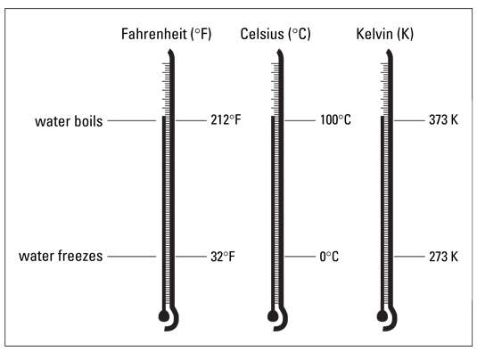
Comparison of the Fahrenheit, Celsius, and Kelvin temperature scales.
Water boils at 100°C (373 K) and freezes at 0°C (273 K). To get the Kelvin temperature, you take the Celsius temperature and add 273. Mathematically, it looks like this:
K = °C + 273
You may want to know how to convert from Fahrenheit to Celsius (because most of us still think in °F). Here are the equations you need:
°C = 5/9 (°F – 32)
Be sure to subtract 32 from your Fahrenheit temperature before multiplying by 5/9:
°F = 9/5 (°C) + 32
Be sure to multiply your Celsius temperature by 9/5 and then add 32.
Try using these equations to confirm that the normal body temperature of 98.6°F equals 37°C.

Feel the heat
Heat is not the same as temperature. When you measure the temperature of something, you’re measuring the average kinetic energy of the individual particles. Heat, on the other hand, is a measure of the total amount of energy a substance possesses.
For example, a glass of water and a swimming pool may be the same temperature, but they contain vastly different amounts of heat. It takes much more energy to raise the temperature of a swimming pool 5°C than it does a glass of water, because there’s so much more water in the swimming pool.
The unit of heat in the SI system is the joule (J). Most of us still use the metric unit of heat, the calorie (cal). Here’s the relationship between the two:
1 calorie = 4.184 joule
The calorie is a fairly small amount of heat — the amount it takes to raise the temperature of 1 gram of water 1°C. The kilocalorie (kcal), which is 1,000 calories, is a convenient unit of heat. If you burn a large kitchen match completely, it produces about 1 kilocalorie (1,000 cal) of heat.
When you hear the word calories, you may think about food and counting calories. Food contains energy (heat). The measure of that energy is the nutritional Calorie (which is commonly capitalized), which is really a kilocalorie (kcal). That candy bar you just ate contained 300 nutritional Calories, which is 300 kcal or 300,000 calories.

The Periodicity of Chemical Elements

8 of 8 in Series: The Essentials of Chemistry Basics
A pattern of repeating order is called periodicity. In the mid-1800s, Dmitri Mendeleev, a Russian chemist, noticed a repeating pattern of chemical properties in elements.
Mendeleev arranged the elements in order of increasing atomic mass, to form something that resembles the modern periodic table. He was even able to predict the properties of some of the then-unknown elements. Later, the elements were rearranged in order of increasing atomic number.
The periodic table enables chemists and chemistry students to:

Learn the properties of families of elements (instead of learning the properties of each element), thus saving a lot of time and effort.

Find the relationships among elements and figure out the formulas of many different compounds.

Examine the atomic numbers, mass numbers, and information about the number of valence electrons.

The elements in the following periodic table are arranged in order of increasing atomic number. The atomic number (number of protons) is located right above the element symbol.
Under the element symbol is the atomic mass, or atomic weight (sum of the protons and neutrons). Atomic mass is a weighted average of all naturally occurring isotopes.
Notice also that two rows of elements — Ce-Lu (commonly called the Lanthanides) and Th-Lr (the Actinides) — have been pulled out of the main body of the periodic table. If they were included in the main body of the periodic table, the table would be much larger.
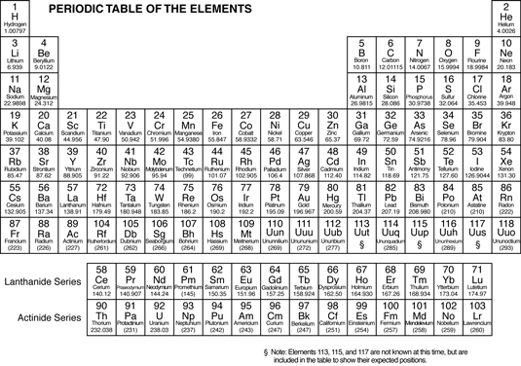
Click here to view this table.
The periodic table is composed of horizontal rows called periods. The periods are numbered 1 through 7 on the left-hand side of the table. The vertical columns are called groups, or families. Members of these families have similar properties.
The families may be labeled at the top of the columns in one of two ways. The older method uses Roman numerals and letters. Many chemists prefer and still use this method. The newer method simply uses the numbers 1 through 18.

