Justice@Home | Fighting Foreclosures and Wealth Transfer
852 Brafferton Place Stone Mountain, GA 30083
Media Advisory | For Immediate Release
Jus | Contact:  Wekesa O. Madzimoyo | Afiya Madzimoyo  404.201.2356 | 404.292.9002  Wekesa@ayaed.com | Afiya@ayaed.com  www.justiceathome.com or www.ayanetwork.com/justiceathome  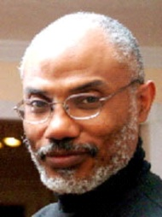  Georgia Homeowner Wins 11th Circuit Court of Appeals Victory: Fight to stop big banks and wealth transfer grows  Atlanta, 10-31-2011 –What started as a simple request by a DeKalb County, GA couple for their bank to assure them that they were making their monthly payments to the right company has resulted in a two-year legal fight to save their home, and an 11th Circuit Court of Appeals victory which, in effect, requires GMAC/ALLY, JP Morgan Chase, and The Bank of New York Mellon Trust Co. to face the music they’ve been avoiding since 2009.  According to Wekesa and Afiya Madzimoyo (plaintiffs), “This 11th Circuit ruling thwarts one of the bank’s favorite strategies – Removal to Federal Court. It paves the way for the homeowners to continue their suit to force the bankers to prove that they have standing to even collect payments from the homeowners. The 11th Circuit’s 3-judge panel’s decision was delivered on Sept. 7, 2011 and mandated on Oct. 12^{th:}  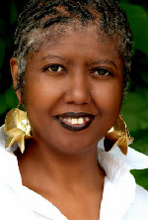  “Upon review of the record, we conclude that the district court should not have exercised federal- question jurisdiction upon removal of this case… Accordingly we vacate the judgment of the district court and remand with instructions that the district court remand the proceedings to the state court. VACATED AND REMANDED”  Afiya Madzimoyo  Wekesa Madzimoyo  Back to “state court” means that the banks have to face a July 2009 State Judge’s order requiring them “bring proper evidence of chain of title.” The GA couple doesn’t believe the banks can do it. “Why else would they fight us for over two years to avoid the Judge’s simple order to provide what they supposedly already had,” asks Mr. Madzimoyo? “Why else would they be trying to make a deal with the States’ Attorneys General for immunity from prosecution?”  While the war isn’t over, Mr. Madzimoyo insists that “this victory gives us hope; provides precedent-setting law that will allow us and other homeowners to stop the fraudulent foreclosures and better hold the banks accountable for the mortgage mess they’ve created.”  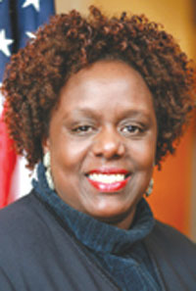  In some neighborhoods in the Atlanta Metro, Black homeowners are severely under water. According to Fulton County Representative, Able Mable Thomas, “You can get homes in my neighborhood for $10K.” In the Atlanta Metro home values are down 50-90%.” Mr. Madzimoyo blames the banks: “From predatory lending, through Mortgage Backed Securities, credit default swaps, and fraudulent foreclosures -- they have thrown me, my neighbors, my neighborhood, and the nation into economic turmoil.” He points to the boarded up houses and abandoned neighborhoods which increasingly dot the Atlanta Metro landscape in the wake of the 2008 economic crisis as his motivation for continuing to fight.  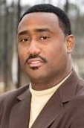  Rev. Derrick Rice, pastor of Sankofa United Church of Christ says “What’s amazing, and inspiring is that the couple has won this victory without any lawyers, and they’ve always been dedicated to helping the community.” Wekesa is an educator – Director of AYA Educational Institute in Stone Mountain, GA. Afiya holds an MSW degree and is the Manager of a COMPRO-TAX income tax preparation office in downtown Atlanta. They have no formal legal training, yet they are a part of a growing national movement of “pro-se” (for self) litigants who represent themselves in court against the giants of the banking industry. In Georgia, many pro se litigants are part of an organization founded by the Madzimoyos called Justice@Home.  Rev. Derrick Rice  Homeowners Organize  What started with the Madzimoyos sharing their fight has morphed into an organization with 100+ petitioners and supporters in the Atlanta Metro and nationally. Justice@Home litigant and educator, Kwabena Ofosuhene, says: “We have to represent ourselves. Most lawyers won’t defend us, and the ones who will take our cases want to charge us and arm and a leg. We’re already unemployed or under-employed. Our home values have dropped so that they are not worth what many lawyers want to charge.”  Monifa Taylor, a realtor, and another Justice@Home supporter adds: “We found that no one will fight for our homes the way we will.”  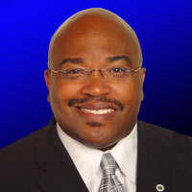  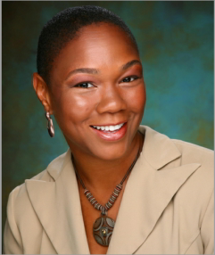  Many Justice@Home families have active cases in Georgia and Federal Courts. These homeowners are supported by seniors, college students, and other volunteers – researching case law, editing documents, educating new-comers, never allowing any member to go to court alone. “We always need more volunteers, says supporter Derek Horne.”  Derrick Boazman  Rep. Mable Thomas  According to Derrick Boazman (Former Atlanta City Councilman, and Convener for Let Us Make Man) “We’re in a state where robo-signing, fraudulent foreclosures and fake document processing centers go unchecked legislatively, so homeowners have turned to the courts.” “Unfortunately,” he says “lawyers are slow to represent those who have little money while facing banks that have pockets as deep as the ocean.” “Sometimes,” Boazman insists that “too many judges and legislators get lost in those deep pockets.”  Deal or No Deal?  Monifa  Taylor  The natural place for citizens to turn would be the State Attorney General’s office. But in GA, the Attorney General (AG) has joined many around the country working to make a “deal” with the banks to preclude them from prosecution for what many Justice@Home petitioners see as their “illegal wrong-doing.”  Georgia’s AG and those meeting to make a deal with the banks--which is closed to public scrutiny-- stand in sharp contrast to Attorneys General from New York, Delaware, Massachusetts, Nevada, and California who are seeking to hold the banks accountable and protect their citizens.  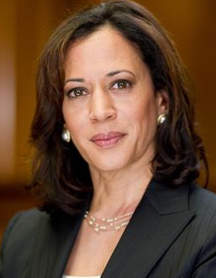  Kamala Harris, AG from California has said this about the deal: “The pending deal is inadequate for California homeowners and gives bank officials too much legal immunity.” CBS San Francisco reported on Sept. 30th that she said: “The state is being asked as part of the settlement to excuse conduct that has not been properly investigated.” AG Harris promised to continue her own investigation. On Oct. 20th the LA Times reported that she had subpoenaed Bank of America.  On the East Coast, Bloomberg Businessweek reported on Oct. 26th that AGs Eric Schniederman (NY) and Beau Biden (Delaware) are investigating the banks for “criminal acts in connection to the foreclosure crisis.”  Boston.com reported that Massachusetts AG – Marth Coakley is preparing to sue “mortgage lenders for foreclosure-related improprieties, including allegations that the companies have threatened homeowners with property seizures and unwarranted fees even after granting them permanent loan modifications.”    The Madzimoyos claim that “Georgia’s Attorney General, Sam Olens fiddles while its homeowners and their neighborhoods burn in the flames of fraudulent foreclosures.”  “Too often,” the Madzimoyo’s say “Jeffrey Stephan, or another ’robo-signer’ like Linda Green exposed by a 6o Minutes broadcast in 2010 strikes the match.” Robo-signers are people hired by the banks to sign tons of land and title documents without verifying the validity of the information and correct notarization. Such action violates state and federal law.  AG - Kamala Harris  Robo-signed and After The Fact:  “That’s who signed the fake assignment in our real estate record,” says Ms. Madzimoyo, referring to Jeffrey Stephan. “He signed a fake assignment 7 months after the bank began foreclosure action against us. How do you foreclose on something today, that you won’t have title to until 7 months later?” “Plus,” she adds with a hands-on-her-hips kind of attitude, “Stephan has admitted under oath in both Florida and Maine that he signed mortgage documents fraudulently. Florida sanctioned him and GMAC for such behavior six months before he signed the after-the-fact assignment in our land record. Months later he was still at it because Maine threw out the bank’s foreclosure case because of his testimony via deposition.”  US District Court Judge, Amy Tontenburg, recently affirmed that Georgia foreclosure laws require that the foreclosing lender be the “secured creditor” when they first advertise to start the foreclosure process. “To cover their tracks, and their after-the fact- robo-signed assignment, Chase and NY Bank of Mellon Trust filed a “corrected assignment” without Stephan’s signature, but fraud - by law - isn’t correctable,” contends Ms. Madzimoyo  Yinka Winfrey - entrepreneur, mother, and another Justice@Home supporter says: “This 11th Circuit Court of Appeals victory will help us continue to fight for homeowners all over GA and the US. It allows us to force the banksters’ (bank + gangster) to prove that they have legal standing to even collect payments from the Madzimoyos and thousands of homeowners in GA.”  Abuse:  According to the Madzimoyos, “The bankers’ key strategy against homeowners who sue them is to ‘remove’ the case to Federal Court.” “It’s a ploy,” they say, “to get homeowners to drop their complaints against them due to the extra work, expertise, or expense needed to plead a Federal case.” “It has worked,” says Afiya Madzimoyo. She recalls: “several Justice@Home petitioners with just cases have crumbled under the weight a federal case with false claims of “federal jurisdiction” and motions for dismissals based on the pleadings.” Ms. Madzimoyo, who has had to get used to such legal jargon, gets teary-eyed as she recalls the homeowners who have lost their homes and life savings to what they call fraudulent foreclosure tactics.  Mr. Madzimoyo, chimes in:  “When you combine Power of Sale abuse with Right of Removal abuse homeowners have little chance of victory, and are robbed of State Court protection against fraudulent foreclosure.”  “In a non-judicial foreclosure state like GA, anyone - and I mean anyone including your next door neighbor- who pretends to be your lender can initiate foreclosure on your property without going to court or proving their legal standing in any court. That’s called the Powers of Sale. They just send you a letter and advertise in the paper.”  “The only way for a homeowner to protect themselves is to file a suit to stop the pretender-lender. That’s what we did- filed suit in State Court to make them prove that they were legally who we were supposed to pay. A State Judge agreed with us, and ordered the pretender-lender to prove that they were the “real” lender or “secured creditor.” To our surprise, the pretender-lender invoked their constitutional Right of Removal.”  Many times – as the 11the Circuit affirmed in the Madzimoyo case – the banks’ claims to support removal to federal court are bogus. “No matter, says Wekesa, “once granted, the home owner is robbed of state protection against wrongful foreclosure.”  In the Madzimoyo case, the US Federal District Court Magistrate Brill and Justice Panell allowed the banks to ignore State Judge Tangela Barrie’s direct order for the banks to “bring proper evidence of chain of title.” Most incredibly, Wekesa adds – “the federal justices went further: dismissing our case and ordering us to pay the banks’ legal fees as they sought to flee the State Judge’s order!”  A Family Fight:    But the Madzimoyos don’t give up easily. “We fought them every step of the way,” says Ife Madzimoyo, honor student at Bennett College in Greensboro, NC and youngest daughter of the Madzimoyos. “The whole family got involved. We’ve defended our home against three different illegal foreclosure attempts while fighting some of the largest banks in the country (Chase, GMAC/Ally, NYBMT) in US Federal District Court.  Sarafina, an entrepreneur at 22, and the oldest daughter said: “They didn’t expect us to appeal to the 11th Circuit Court of Appeals. Most everyone thought my parents were crazy; even those who believed our cause was just didn’t see how we had a chance of overturning the US District Court ruling.”    Mr. Madzimoyo says: “To be frank, our knees wobbled a few times. But my wife Afiya is from an Independence, Alabama family – The Cavers who are known for fighting against injustice. Her great uncle Jake’s voice would steel her: “We’ll see who shall or who shain’t be whipped.” My fighting inspiration came from my mother, Maggie Tucker-Wright of Fayetteville, NC, who always told me “Son, never tell yourself no, and remember: nothing beats a failure, but a try.”  Sarafina Madzimoyo  Ife Madzimoyo  “Our victory is controlling law in Georgia, Florida, and Alabama; and it is influential law, nationally. It can be used by homeowner litigants, lawyers and community groups to thwart the banks power of sale and right of removal one-two punch,” says Mr. Madzimoyo. “We share our information help them fight fraudulent foreclosures.” See: www.justiceathome.com  New State Complaint:  The Madzimoyos have initiated a new state complaint against the same banks. Wekesa explains: “It goes directly at the fake assignment-making machinery and the banks’ mortgage-backed-securities schemes and scams which break state land title laws that have protected homeowners and home buyers for over 100 years.”  It’s a David and Goliath battle to be sure, but all the battles haven’t had the Biblical ending. Afiya says: “Too many times, Goliath wins. Too many of our friends have been cheated out of their homes, and that’s why we will continue to fight, heal, and build.”  Justice@Home:  The group’s main goals are fighting, educating, and healing. “  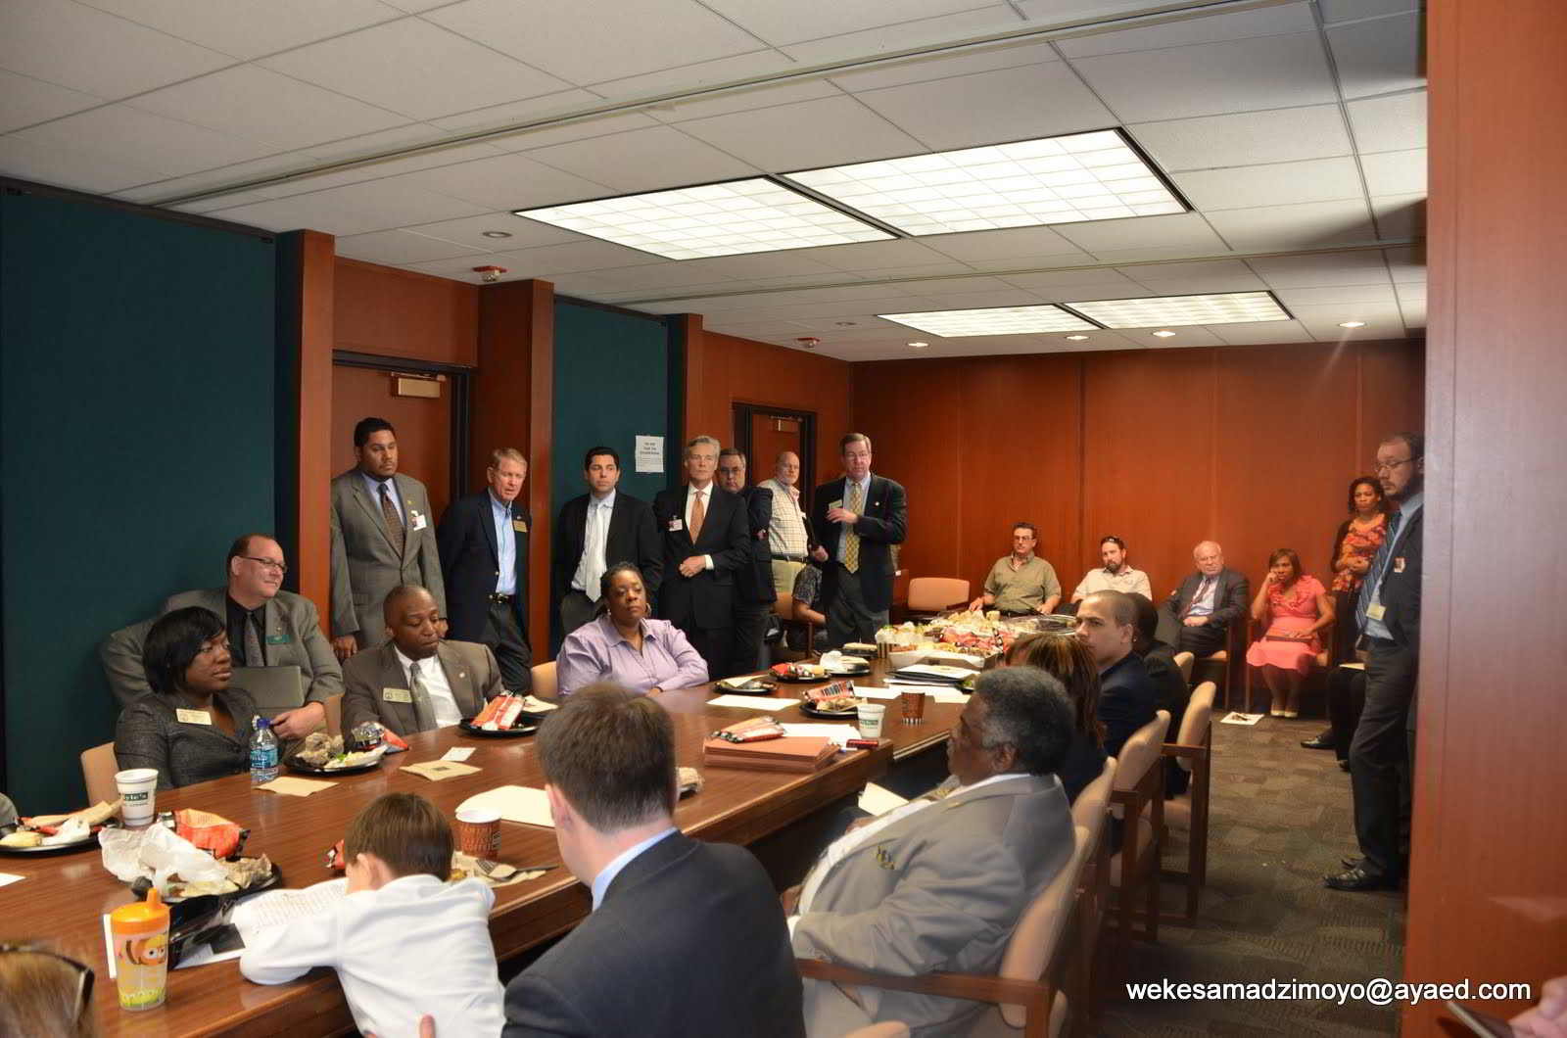  Justice@Home presents to DeKalb County, GA Legislators  “Most people don’t really know why banks don’t want modifications to succeed; they don’t know how the incentive structure has changed so that banks make more money when you default. Judges and legislators don’t know that more money is made by the banks betting on your mortgage failure, than on your principal and interest, so we educate them,” says entrepreneur Damani Aaquil, another of the group’s supporters.  Wekesa says, “We must also heal our community. Many people suffer in silence blaming themselves for all of this. That blame induced by the banks initially calling this the “subprime” mortgage crisis, caused by “deadbeat” homeowners, stops people from seeking the redress they are due, and getting the support they need and deserve.”  “While we know that many in the country are hurting, few realize the blow to Black wealth. Our schools are closing and nearly 100 churches have been foreclosed upon in the Atlanta Metro area alone. The wealth gap between the Black and White communities has exploded from 10:1 in 2006 to 20:1 in 2011.” “It’s like some demonic suction tube; our wealth was in our homes,” says Afiya.  Flipping The Script:  Justice@Home also builds. It trains and supports homeowners to create home-buying collectives where homeowners can purchase homes free and clear in less than 3 years. At a time when access to traditional loans is limited, Black home owners can’t take advantage of low home prices. Unemployment in the African American community is twice the national average. Under-employment is even greater. Add to this the bank’s tightening their lending policies, now requiring higher credit scores to qualify for mortgage loans. What’s one to do? Madzimoyo says, for those who are fighting the banks or willing to support those who are fighting, we help them use our collective wealth by earning credibility among ourselves – our people.    Esusu and collective buying isn’t new. Esusu is Yoruba, from Nigeria. It’s just “susu” in the Caribbean, but the names for collective financing vehicles based on group trust are many throughout Africa and the Diaspora. At specified intervals a member of the group gets the “pot” in rotation until all have received it.  Already, fighting homeowners and supporters of Justice@Home are buying homes free and clear. The key, according to Esusu member, and substance abuse counselor  - Jahfari Nyahbinghi, “is the special training designed to heal oppression’s wounds.” “It is on-going training,” she says, designed to build a working trust among group members. As the group’s currency grows; so must individual and group trust. We no longer trust the banks, the regulators, the legislators – we are learning to trust ourselves, to “bank” on ourselves, again.”  Jahfari Nyahbinghi  While there are many pro se litigants around the nation who are using the internet to bring court action, Justice@Home represents a unique gathering of neighbors in a metro area coming together to exhort and support each other to legally sue the banks, force legislative action, and build safe alternatives to bank financing. They’ve been meeting every Tuesday night for nearly two years now and have four committees:  - Pro se Litigation (home-owners and supporters who are representing themselves in court)  - Move Your Money (Divestment) Stop supporting banks that are foreclosing.  - Petitions To Attorney General and County Registrars (to pursue banks for fraud, and for payment of registration fees )  - Esusu – Home–Buying Collective (Home-owners diverting their mortgage monies to a collective fund to buy homes free-and-clear in under 3 years.)  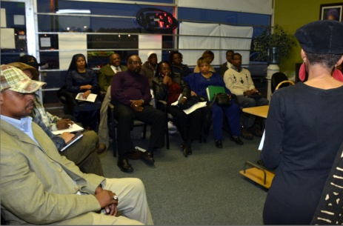  The Madzimoyos speak around the state and the country spreading hope and strategies for ordinary homeowners to win against the odds. While they savor this victory, they know that the war is a protracted one.  Justice@Home Meeting  Wekesa Madzimoyo says that Justice@Home has recently joined with Occupy Atlanta and the Occupy Wall Street movements globally. He resolves: “Our cause is just, and we will fight until we win, until we get Justice@Home.”  In the Bible story, David wins, and Davies goes to hell; in Georgia – we’ll have to see.  Contact Info:  Justice@Home: 852 Brafferton PL. Stone Mountain, GA 30083  Call 404.201.2356  Website: www.justiceathome.com  Attend telephone and online meetings on Tuesday 7pm, EST  Call-in #: 605-475-4800, then pin: 779-366#  Web Conference Link:

